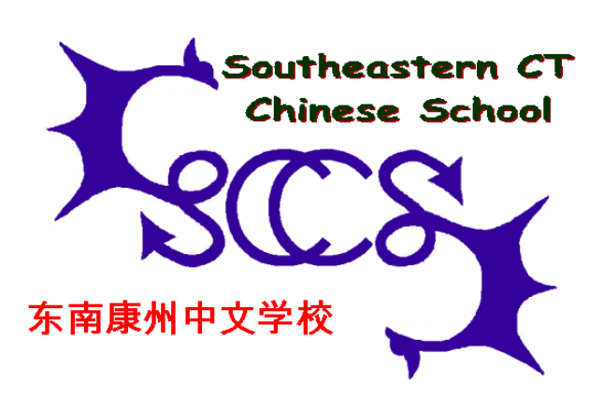
Student & Parent Handbook

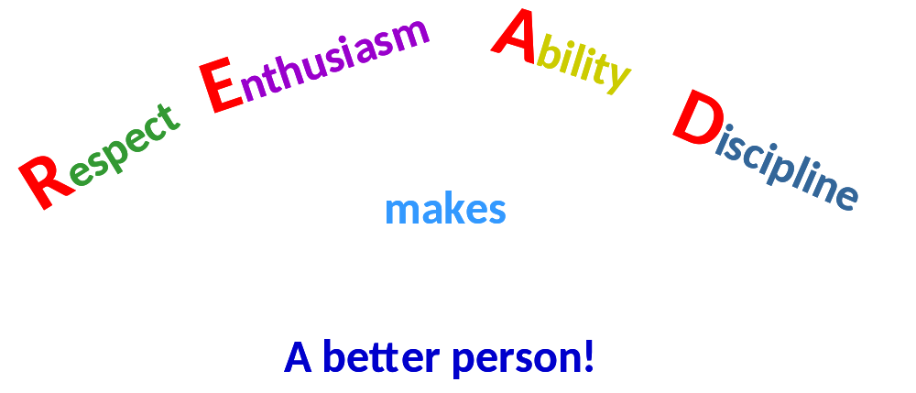

This handbook belongs to:

Name: ________________________________

Class: _________________________________

Parent Signing Sheet

I have read this <Handbook> and explained the contents to my children. We agree to comply with SCCS rules and policies described in this book. We understand that we will be responsible for consequences of any violations.

我已通读了这本手册，并将其内容对我的孩子作了解释。我们都愿意遵守东南康州中文学校所制定的校规，并同意对违反校规所造成的后果负责。

学生姓名（Student Name）： _________________________

家长姓名（Parent Name）： _________________________

家长签名（Parent’s signature）: _________________________

Use of student’s images for SCCS educational and promotional purpose

我愿意让我孩子的照片或录像被用于东南康州中文学校教学或公共关系宣传。I grant SCCS permission to use images of my child(ren) captured by photograph or video-recording devices for promoting SCCS educational or public relation purposes. I understand that I have the right to cancel the permission after reviewing the images at public display or disclosure by SCCS any time. In such a case, I shall inform SCCS administration my decision in writing.

我不愿意让我孩子的照片或录像被用于东南康州中文学校教学或公共关系宣传。I do not grant SCCS permission to use images of my children captured by photograph or video-recording devices for promoting SCCS educational or any other purposes.

学生姓名（Student Name）： _________________________

家长姓名（Parent Name）： _________________________

家长签名（Parent’s signature）: _________________________

Emergency Medical and Liability Release
Fall 2011 – Spring 2012

In case of emergency, permission is hereby given to my child(ren) and adults

____________________________________________ (name of 1st child)

____________________________________________ (name of 2nd child)

____________________________________________ (name of 3rd child)

____________________________________________ (name of 1st adult)

____________________________________________ (name of 2nd adult)

To be treated by the doctor or hospital appointed by the Southeastern Connecticut Chinese School, Inc.

I/We hereby release, discharge and agree to save harmless the Southeastern Connecticut Chinese School, Inc., their legal representatives or assignees, and all persons acting under their permission or authority, from any liability whatsoever for any and all claims of any nature which may arise out of my children’s attendance to the School.

Parent/Guardian (Name in print and signature)

________________________________________________________________________
Emergency Contact Person and Number

Date

Table of Contents

General Information about the School 6
Code of Conduct for the Students 8
READ - Respect, Enthusiasm, Ability and Discipline 8
Rules for Using School Facility and Parking 10
About East Lyme High School Facility 10
About Parking 13

Southeastern Connecticut Chinese School, Inc. (SCCS)
30 Chestfield Road
East Lyme, CT 06333

Information Hotline: 860-884-9990

Website: http://www.ctsccs.org

General Information about the School

The Southeastern Connecticut Chinese School, Inc. (SCCS) was founded in late 1970’s by a small group of parents (about fifteen families) on volunteer basis in a local public library. The school received its non-profit organization status in 1997 and was relocated to East Lyme High School in September, 2010. Today SCCS has become a well established non-profit organization with the aim of preparing students to be well-versed individuals working in a multi-cultural environment through its curriculum. Current students are primarily from New London, Norwich, and New Haven area in Connecticut and from southern Rhode Island. SCCS offers classes from 9:30 AM to 12:45 PM Sunday mornings at East Lyme High School in East Lyme, Connecticut. The school year begins in September and ends in May. In the fall semester of 2010, there were 334 students (parents’ class excluded).

SCCS offers more than 40 courses in Chinese language, AP/SAT Chinese, Basic Studies of China, Math, Technologies, seminar on Globalization, Drawing, Dance, Chess, Chinese and Western Music, Guitar, Yoga, Basketball, Martial Arts and others. Classes are open to anyone who is interested in learning Chinese language, culture, or in any other courses that SCCS offers, and is willing to obey ALL SCCS Rules and Policies.

SCCS has launched a "500 + 3" Program. For students who are enrolled in Chinese language classes their goals are to master at least 500 Chinese characters, to independently write at least one article in Chinese, to participate in at least one Chinese speech contest, and to fluently read at least one article in Chinese within 8 years of study.

All SCCS teachers and staff are professionals from statewide businesses and companies, local schools and artist studios. Some are certified teachers in Connecticut public schools. Many of them have advanced degrees in various fields of liberal arts, science and engineering. Some have past teaching experiences and a few are still holding teaching positions in local colleges and schools. SCCS holds regular training sessions for teachers to assist them constantly updating knowledge and improving teaching qualities.

SCCS offers scholarships to selected local high school students every year. It also offers many volunteering opportunities for the SCCS students. For example, the Teaching Assistant Program offers teaching opportunity to selective talented local high school students who volunteer to work with SCCS teachers in classes as teaching assistants. The Student Leadership Program offers SCCS students an opportunity to work with school administrators and teachers to organize school activities, such as Chinese Speech Contests, Talent Shows, etc. The Community Outreach Program let our teachers and students promote Chinese culture in local business and nursing homes in Chinese New Year and other events. In collaboration with SECCCS (Southeastern Connecticut Chinese Culture Society), SCCS also organizes events outside the classrooms, such as Halloween activities, Egg Hunting, Movie Day, etc.

Code of Conduct for the Students

The Southeastern Connecticut Chinese School developed the policies and rules outlined in this handbook to ensure a safe and orderly school environment. However, these policies and rules will not be effective unless each and every student chooses to cooperate. Therefore, we request our students and their parents to carefully read and understand the information in this handbook and to support our effort to create a school climate, which will facilitate positive academic and social growth.

READ - Respect, Enthusiasm, Ability and Discipline

READ is the motto of our school. Acting with READ in mind will insure an environment that will allow each and every student an opportunity for success in our school, in their respectively regular school, and in their life and future career.

Respect: Respect is the foundation from which our students build mutual trust and self-esteem. Each student has the RIGHT to be respected, be treated with kindness and caring, and be listened to and heard. The school also expects each student to express ideas and feelings in a polite manner. Respect yourself, your fellow students, your parents, and your teachers.

Enthusiasm: When a student develops an interest in the subject(s) to be learned, learning becomes fun. SCCS teachers promise to do their best in preparing for the classes. The school also expects that each student be an enthusiastic learner — well prepared and active in class activities.

Ability: SCCS recognizes that each student has different interest and talent, so the school offers a variety of classes in various subjects to meet the students’ needs. However, to develop one’s skills to the fullest potential, one has to challenge oneself to study hard. “Success is 1% inspiration and 99% perspiration.” SCCS expects students coming to the school to do their best in order to develop all the skills to be well versed to work in a multi-cultural environment in the future.

Discipline: SCCS must be a place where students, staff and visitors feel safe; it must be a place where no one is afraid of physical or emotional harm. Therefore, SCCS has a policy of zero tolerance for any episode of verbal abuse, improper gestures, or physical aggression. It is important that students and parents understand what this policy means. No episode of aggression, verbal or physical, goes unaddressed at SCCS. When teachers, parents, and administrators become aware that a student has harmed another in word or in deed, the episode is addressed. In some cases, and based on the severity of the incident, this response may be educational rather than punitive, and in any case of repeated aggression consequences are progressive in nature. Parents are informed when students are involved in aggressive behavior. Consequences for aggression may include: detention, in-school or out-of-school suspension, notification of parents and/or police, and expulsion from school.

Rules for Using School Facility and Parking
SCCS is a community-based, self-funded and self-governed non-profit organization.

SCCS welcomes all students and parents who agree to comply with the rules and policies

described below.

About East Lyme High School Facility

• As SCCS uses the East Lyme public school facilities, including class building and parking lot, we require all our teachers, students, parents and visitors obey all East Lyme public school rules and regulations.
• All classes should start and finish on time (9:30 – 11:05; 11:10 – 11:55; 12:00 – 12:45).

- All classrooms, restrooms, hallways and stairways must be kept clean and tidy.
• Running and loud talking are prohibited in ANY PLACES inside of the building.
• Do not touch the fire alarms unless there is a fire.
• Relocating any of the building properties, e.g. desks, chairs and chalks, is not allowed without permission of SCCS teacher in the class.
• Drinks, other than Water, and snacks are ONLY allowed in the designated area in cafeteria.
• Any used class materials, e.g. paints, paper, pencils, etc., must be carried away or discarded into trash bins at the end of the class.
• Do not use chalks or dry markers unless instructed to do so by the teacher.
• No writing or drawing on the chalkboard is allowed unless instructed to do so by the teacher.
• Absolutely no writing or drawing on the walls, desks or any other building properties is allowed.
• No breaking or altering any of the building properties or belongings, e.g. copy machine, vending machine and post board, is allowed.
• No banging on the door is allowed when entering or exiting a classroom.
• Do not disturb any class still in session by knocking or opening the door.
• Practice good personal hygiene when using the restrooms.
• Do not use any supplies inside any classroom. Use SCCS supplies only.
• Each classroom and gym courts should be cleaned up after each use and returned to original configuration.
- Other than those directly related to school sponsored programs and activities, any distribution of materials inside the building and in the parking lot while SCCS is in session needs prior written permission from both SCCS administration and the Board of directors.
- Any materials published, posted or otherwise distributed shall bear names of at least three SCCS students and SCCS teachers principally involved in the promotion of the materials and, when applicable, the name of the sponsoring organization or group.
- Any materials published, posted or otherwise distributed shall not imminently threaten to disrupt the educational process of the school. Distributors of materials will be held responsible for cleaning up litter caused by such distribution. Violators will be warned and fined; and the permission will be revoked as judged necessary by the SCCS administration and the Board of Directors.
- As SCCS only uses a portion of the ELHS facilities and SCCS is responsible for paying for janitorial service, only parents and guardians are allowed to stay in designated area while the school is in session. No ones, including students, staffs, parents, and guardians, are allowed to use any facilities other than those designated for SCCS use.
- Without exception, visitors are required to report to the SCCS principal on duty at duty. Only under unusual circumstance and with prior approval of the SCCS administration and the classroom teachers, will students be allowed to have visitors other than parents or guardians during the school hours. All visitors must sign in at the SCCS office, obtain a visitor’s badge, and wear the badge throughout the visit. Any person on campus without permission from the SCCS administration and the Board of Directors will be treated as a trespasser.
- Social events are scheduled periodically during the school year; only SCCS students, staffs, parents, guardians, and invited guests may attend these events. Students may be excluded from any event due to disciplinary concerns.
- SCCS reserves the right to create special committees to screen the contents of academic programs and supporting programs.
- Students and parents must follow the instructions issued by the special committee during the social events.
- During SCCS sponsored social events and in SCCS, photography and audio or video-taping of the activities, students, and staffs are strictly prohibited except by the SCCS designated photographers and recorders, who may do so for promoting the SCCS and for publishing in SCCS newsletters with the permission from SCCS administration and the Board of Directors. In addition, prior written permission has to be obtained from any student and staff whose images are recorded by the photography and/or the video recorder before any public display or disclosure.
- No display and/or distribution of any images of SCCS sponsored activities, students and staffs, whether in physical form such as a poster or in digital form such as uploading to a website or social media site, are allowed without explicit prior approval from SCCS administration, the Board of directors and prior written permissions from parents and guardians whose children‘s images are captured in a medium such as photographic film, audio/video tapes, and digital storage media.

Violator of these rules may face the following consequences, judged and issued by SCCS management and the Board of Directors: out-of-school suspension, notification of parents and/or East Lyme police department, fines and expulsion from school. It is important to know that, in addition to the actions taken by SCCS, the parents or the legal guardian(s) of an individual responsible for damage have to pay restitution for the damage caused by the individual, and may also pay fines levied by the police, the ELHS, or the town to East Lyme.

About Parking

Parents, teachers, and students have the right to use the parking lot(s) of East Lyme High School for attending SCCS classes and related activities during the school days. You may arrive up to half hour earlier (9 AM) and leave up to 30 minutes later (1:15 PM) providing you obey the following regulations.

• Parking of all vehicles must be in the designed parking areas of East Lyme High School. There are three parking lots in East Lyme High School. You may park in any of the three lots.
- All vehicles must strictly follow speed limits and pedestrian signs defined by East Lyme Police department.
• Dropping-off and picking-up of students must take place after the vehicle is completed stopped.
• Children younger than 12 years of age must be escorted by their parents or other adults when transferring between the building and the parking lot(s).
- No running is allowed while going between the parking lot(s) and the building.

Violation of these regulations will result in the following action(s) by SCCS management:
• 1st violation: written warning letter and a fine of $20 to $50;
• 2nd violation: fine of $50 to $100;
• 3rd violation: fine of $100 to $500;
• 4th violation: fine of $1,000 and expelled from SCCS immediately.

In addition, parking and traffic violations may subject to fine and legal action by East Lyme police department. It is the responsibility of the violator, not the SCCS, to pay the fine and to deal with the legal consequence.

SCCS will review the above rules and policies periodically and reserve the right to update the Facility Rules and Parking Rules and to adjust the fines accordingly. The right to interpret ALL the rules and regulations belongs to SCCS.

